P3.Logical ERD

Based on the instructor’s feedback of the initial ERD, each team will make improvements to the initial ERD. Most likely, these changes will be regarding further ‘normalization’ of the database entities, reducing redundant data, and recognizing additional entities.

In addition to submitting a fine-tuned ERD, **each team will also submit a brief description identifying the changes made to the initial ERD**. It is also important to update the design document to reflect the new design changes. Resubmission of the updated design document is not required at this time.

This revised version **must be a logical data model containing no multivalued attributes, no composite attributes, and no many-to-many relationships.** All entities must have a primary key, and foreign keys for any relationships they participate in. Also, the model must be in third normal form, unless there is an explanation for situations where denormalization makes sense.

**Description of changing:**

We transferred entities from the conceptual model into tables, adding primary keys and foreign keys to establish more logical relationships.

ERD:

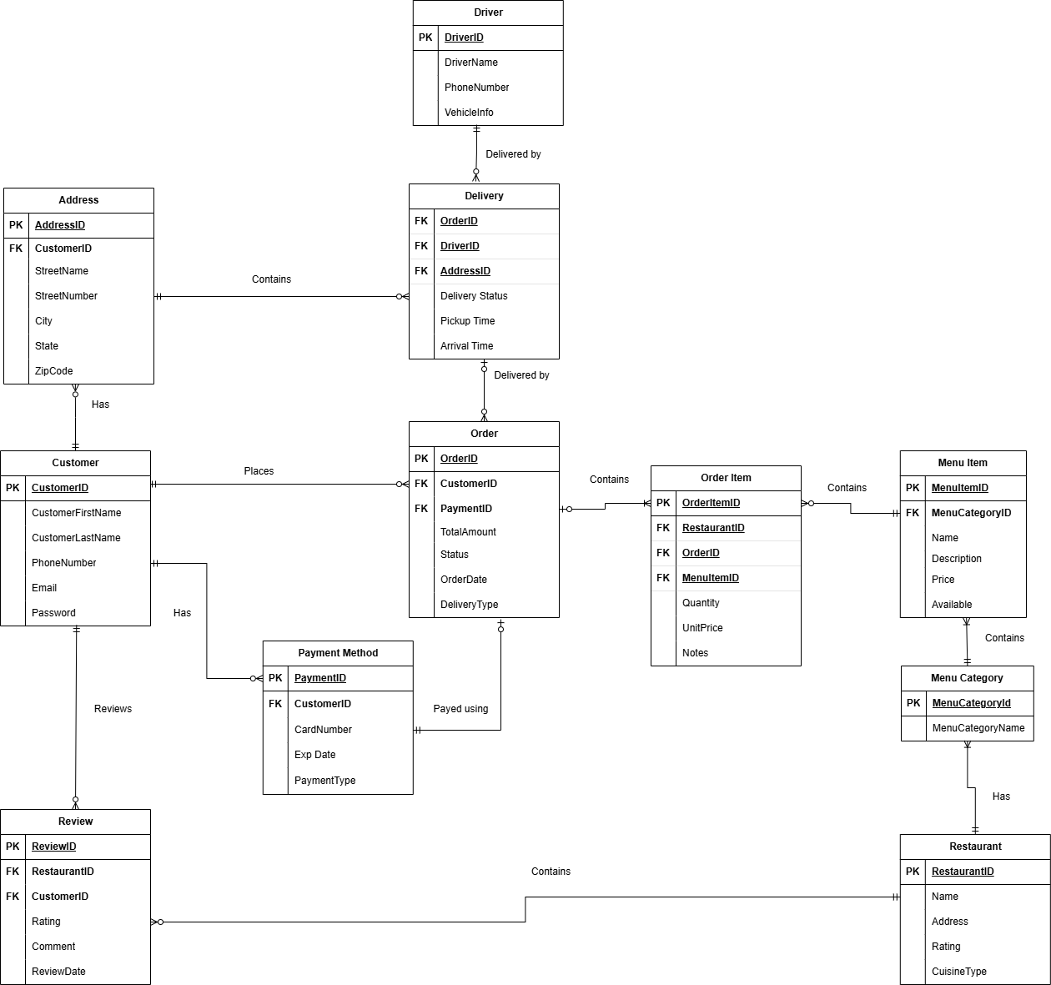

**Entities:**

1. Customer
   * **Description:**
     + A customer is a necessary part of the food delivery system since there are many customers who can place orders at restaurants
     + Related to Address, Order, PaymentMethod, and Review
     + A customer can have multiple addresses, can place orders, can have multiple payment methods, and can add reviews at restaurants
   * **Attributes:**
     + CustomerId(PK), CustomerFirstName, CustomerLastName, PhoneNumber, email, password
2. Review
   * **Description:**
     + A review is written by a customer. Each review is associated with only one customer and one restaurant, while a customer can write multiple reviews.
   * **Attributes:**
     + ReviewID(PK),RestaurantID(FK), CustomerID(FK), Rating, Comment, ReviewDate

1. PaymentMethod
   * **Description:**
     + A customer can have multiple payment methods associated with their account
     + Each order can have one or none PaymentMethod; if the order is for pickup, no PaymentMethod is required
   * **Attributes:**
     + PaymentID(PK),CustomerID(FK),CardNumber, EepDate, PaymentType,
2. Address
   * **Description:**
     + A customer can have multiple address associated with their account
     + If the order is made out for delivery then an address must be included, however not every Address on file needs to have a delivery or delivery history
   * **Attributes:**
     + AddressID(PK), CustomerID(FK), StreetNumber, StreetName, City, State, ZIP
3. Order
   * **Description:**
     + The entity that links a customer, restaurant, and delivery person. It tracks the order status and timestamps, manages the total amount, and handles the delivery location.
   * **Attributes:**
     + OrderID(PK),CustomerID(FK),PaymentID(FK), Total_amount, Status, OrderDate, DeliveryType
4. Delivery
   * **Description:**
     + The entity that manages the delivery process by linking an order to a driver. It tracks the delivery status, pickup time, and arrival time to ensure timely and efficient order fulfillment.
   * **Attributes:**
     + OrderID(FK),DriverID(FK), AddressID(FK), Delivery Status, Pickup Time, Arrival Time
5. Driver
   * **Description:**
     + Drivers are an important entity of this system since they are the mediator between the product and the customer
     + Related to the Delivery since they can do multiple deliveries for customers
   * **Attributes:**
     + DriverID(PF), DriverName, phoneNumber, vehicleInfo
6. OrderItem
   * **Description:**
     + The item that is part of the customer order and is linked to the corresponding MenuItem, can have multiple of the same MenuItem, basically a customized version of MenuItem
   * **Attributes:**
     + OrderItemID(PK), RestaurantID(FK), OrderID(FK), MenuItemID(FK), Quantity, UnitPrice, notes
7. Restaurant
   * **Description:**
     + A key component that contains the products that customers order, can contain multiple categories (Lunch, Dinner, Breakfast, etc), and have multiple reviews
   * **Attributes:**
     + RestaurantID(PK), Name, Address, Rating, CuisineType
8. MenuItem
   * **Description:**
     + The item that a customer can choose from a restaurant/store
   * **Attributes:**
     + MenuItemID(PK),MenuCatagoryID(FK), Name, Description, Price, Available
9. MenuCatagory
   * **Description:**
     + Restaurants have multiple categories of items that allow for easier browsing for customers
   * **Attributes:**
     + MenuCategoryID(PK), MenuCategoryName